Design File

Title and Authors

- Phase 1.
- Group Members: Pablo Ruiz

Purpose of the Phase

- The purpose of phase 1 was to create a server and a client with assigned sockets and have them communicate back and forth using the UDP protocol.

Code Explanation

server.py

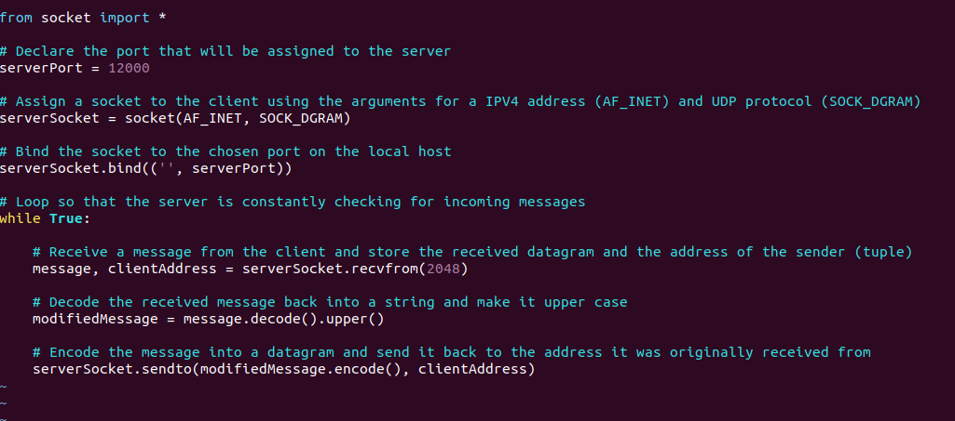

client.py

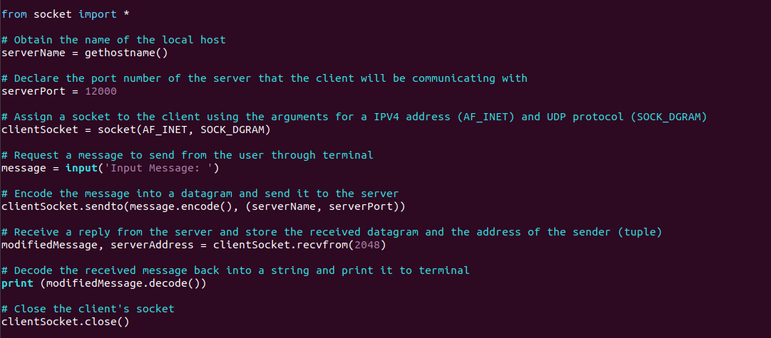

Execution Example

